EXP:3
Implement a C Program to Merge two Arrays
AIM:
Merge two integer arrays into one array by concatenation.
ALGORITHM:
- Read sizes m,n and elements of both arrays
- Copy all elements of first array into result.
- Append all elements of second array into result.
PROGRAM:
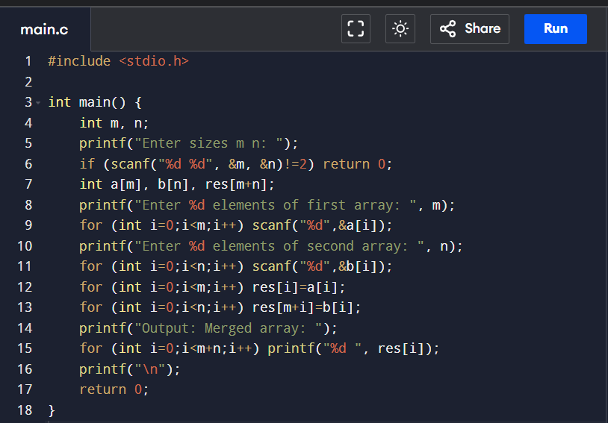
OUTPUT:
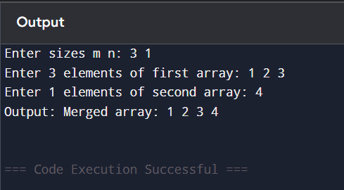
RESULT:
Two arrays concatenated and printed.

